To celebrate the release of Vault 2015 R2, I wrote an app that lets you generate BOM reports automatically through the Vault job server.
If you are not already aware, Vault 2015 R2 has a BOM Report feature. From any BOM view, you can run the Report command and it will generate a report of the BOM that you are viewing. This report uses the same engine as File and Folder reports, which has a good deal of customization options. There are also default templates to help you get started quickly.
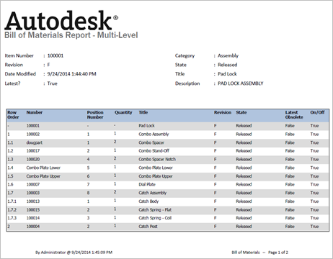

However, the out-of-the-box BOM Report feature is a manual process. If you want to automate things, my plug-in hooks to job server and lets you trigger reports when items change state. When the job runs, it generates the report, saves it to Vault as a PDF and attaches it to the item.
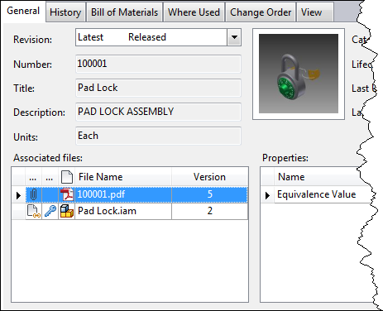

Requirements:
- Vault Professional 2015 R2
- Must have job queue enabled.
- Must have a “Quick Change” state that the plug-in can use to move the item to edit mode.
- Must have a folder in Vault for storing the generated reports.
Click here to download the application
Click here to download the source code
To configure BOM Reports, install the app and follow the readme. You can find the readme in the install location (%ProgramData%\Autodesk\Vault 2015 R2\Extensions\BOMReportJob). Administrative rights are required to configure the Vault job server.

All the apps on this blog have a legal disclaimer on them, but I want to make this one more obvious since it’s dealing with BOM data. BOM Report Job is not an official product. It’s technically classified as a sample app. So please keep that in mind when using these reports. For example, if you are using the report to purchase $50,000 worth of parts, you may want to double check the numbers first before putting the order in.

